How to…



GoogleMap Editor



Umbraco 6

1. Install

Google maps Umbraco 6 package is available at Umbraco community website in project section. You can either download it from repository and then install it in Umbraco or install it directly from repository through Umbraco package interface.

The package URL is [http://our.umbraco.org/projects/collaboration/googlemap-editor](http://our.umbraco.org/projects/collaboration/googlemap-editor%20)

1. Configure

As soon as package is installed you will have it available in Developer section under DataTypes as GoogleMapEditor.

By accessing this node you will see options to configure your editor how you want it to be shown when you are populating value for the property.

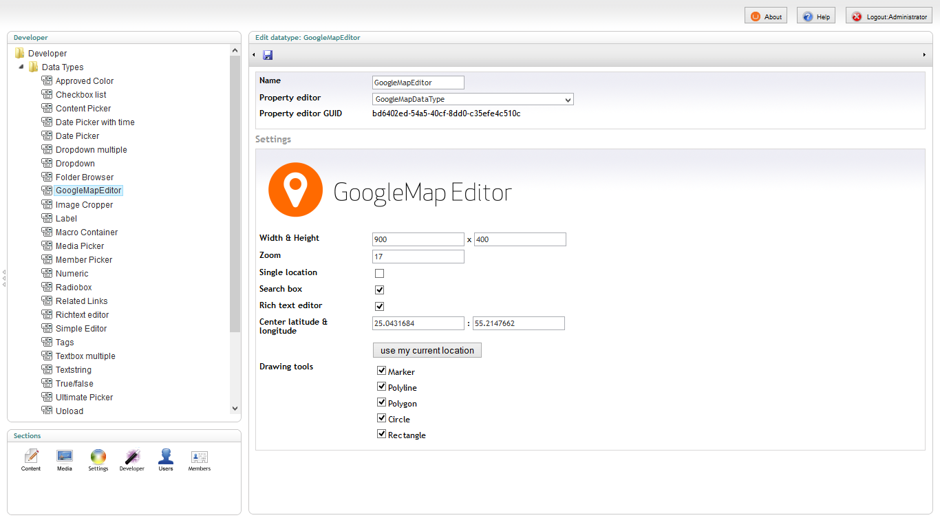

1. Extend custom pin icons  
   Package comes with few custom icons for pins, but it is really easy do ad your own pin icons. Item list is populated from folder /Umbraco/Images/MapPins/.   
   Simply copy your pin icons to this folder and they will appear in edit balloon window in your editor.
2. Use it

Simply adding a property to a document type with type of **GoogleMapEditor** you will have editor with your settings enabled for adding locations to document property.

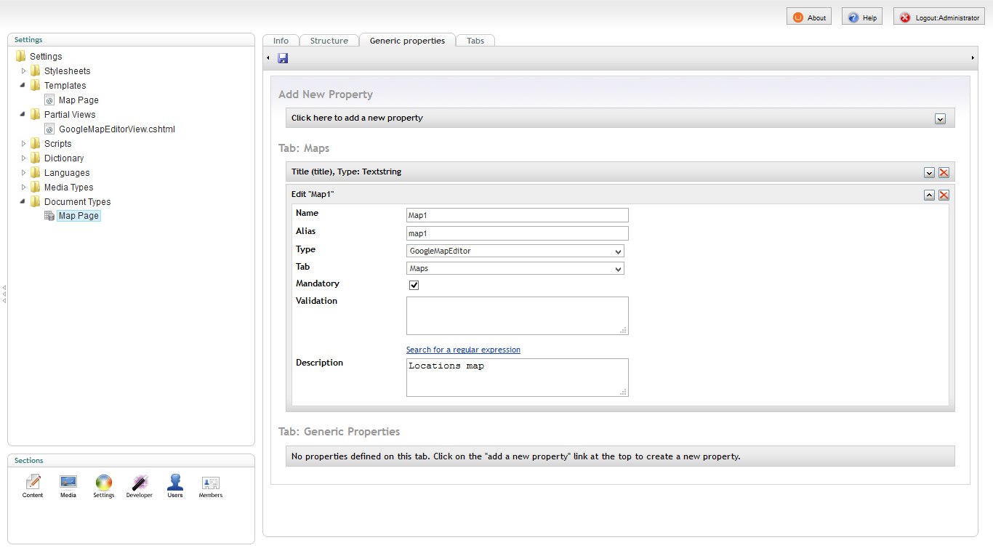

As soon as you switch to content section you will have your editor ready for using.

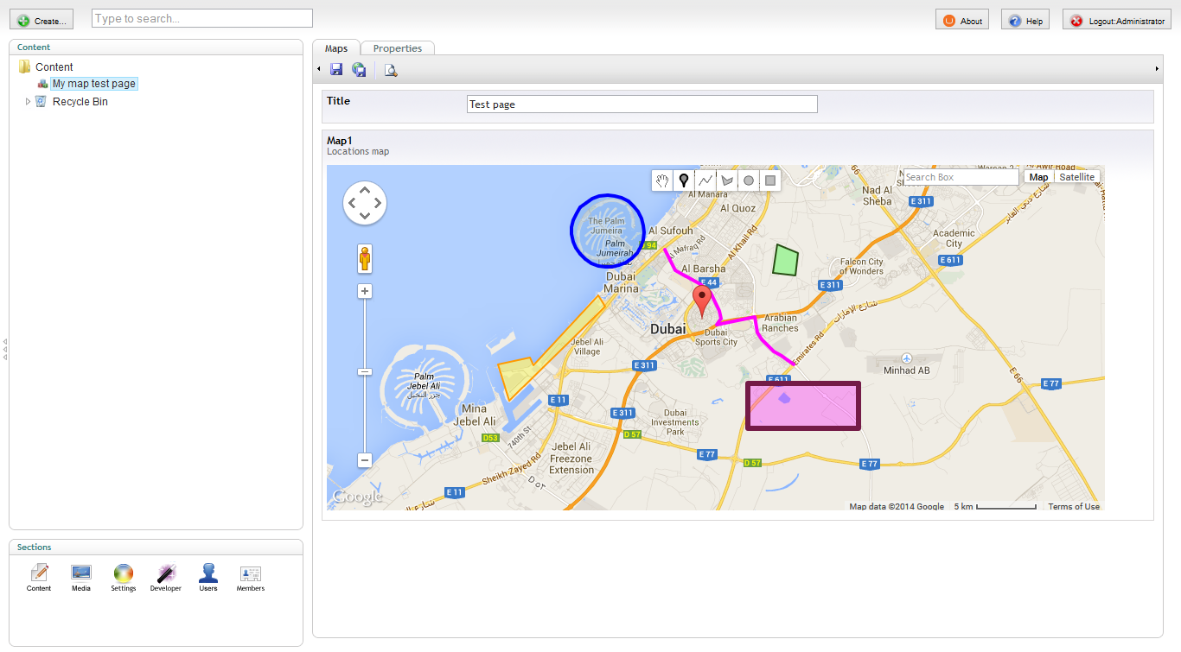

The package comes with a sample partial Razor class which will be added to /Views/Partials/ folder of your Umbraco website.

@model Umbraco.GoogleMaps.Models.MapState

<script type="text/javascript">

if (typeof jQuery == 'undefined') {

document.write(unescape("%3Cscript src='//ajax.googleapis.com/ajax/libs/jquery/1.11.0/jquery.min.js' type='text/javascript'%3E%3C/script%3E"));

}

if (typeof GoogleMapViewer == 'undefined') {

document.write(unescape("%3Cscript src='/Umbraco/Api/Resource/GetEmbdededJavaScript?filename=jquery.googlemapview.js' type='text/javascript'%3E%3C/script%3E"));

}

</script>

<div class="google-map" style="width: @string.Concat((Model.Width>0?Model.Width.ToString():800.ToString()),"px"); height: @string.Concat((Model.Height>0?Model.Height.ToString():400.ToString()),"px"); display: none;">@Model.ToJSON()</div>

<script type="text/javascript">

$(document).ready(function () {

$(".google-map").not("[data-rendered]").GoogleMapViewer();

});

</script>

Sample partial view GoogleMapEditorView.cshtml which comes with the package itself

To render out this partial on a page which has map property, you just need to pass a **MapState** model instance which you can simply acquire with and extension method for **IPublishedPage** which is built in a package library (Umbraco.GoogleMaps.dll).

@inherits Umbraco.Web.Mvc.UmbracoTemplatePage

@using Umbraco.GoogleMaps.Extensions

@{

Layout = null;

}

<!DOCTYPE HTML PUBLIC "-//W3C//DTD HTML 4.01 Transitional//EN">

<html>

<head>

<meta http-equiv="content-type" content="text/html; charset=windows-1250">

<title>@Model.Content.GetPropertyValueAsString("title")</title>

</head>

<body>

<h1>@Model.Content.GetPropertyValueAsString("title")</h1>

@Html.Partial("GoogleMapEditorView", Model.Content.GetPropertyValueAsMapState("map1"))

</body>

</html>

Sample page how to use provided sample partial

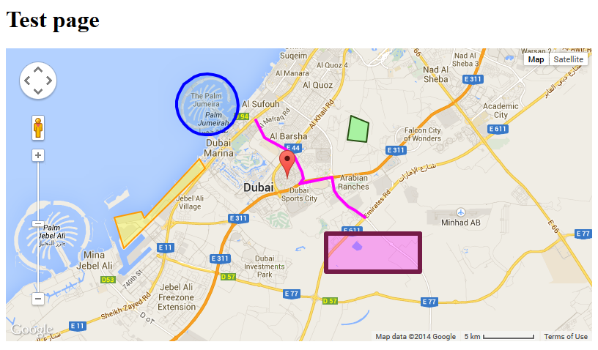

1. Report an issue

All suggestions, issues, ideas, bugs... you can report directly to a GitHub issue tracker at <https://github.com/dejanstojanovic/Umbraco-GoogleMap-Editor/issues>

1. Contribute

This project is opened for collaboration so you can contribute by writing code solutions, documentation or by testing it and reporting issues directly on a GitHub repository where this project is hosted for collaboration.

The project repository URL is <https://github.com/dejanstojanovic/Umbraco-GoogleMap-Editor>